**Green Society Public School**

**D-24**

**Ratnanagar-7, Sauraha, Chitwan**

**First Term Examination-2082**

**Class:3 Time: - 1 hrs. F.M.:25**

**Sub: Science**

|  |
| --- |
| **Name: Roll No.: Sec.:** |
| **OBT.MARKS:** |

**Q.no. 1. Fill in the blanks by choosing the correct word. [4]**

(telephone, junk, science, thin)

a. Scientists are people who know_____________________

b. We should avoid eating _____________________food.

c. We should wear _____________________clothes during summer season.

d. _____________________is two – ways mean of communication.

**Q.no.2. Write True or False. [4]**

a. Watching TV is a type of physical exercise._______

b. We get honey from honey bees.___________

c. We should brush our teeth once a week._________

d. We can learn science by writing only.___________

**Q.no.3. Match the following. [4]**

Hanky learning by doing

Living things cleaning ears

Kinesthetic learner covering mouth

Ear buds can grow

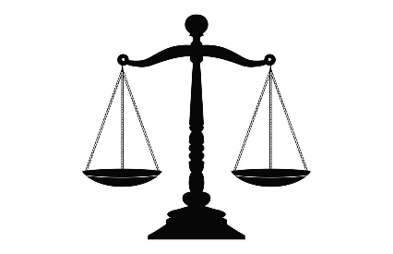**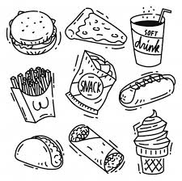Q.no.4. Identify the picture. [4]**

**Q.no.5. Answer the following questions. Do any three. [6]**

a. Why should we read books?

__________________________________________________________________________

b. What is personal hygiene?

__________________________________________________________________________

c. Write any 2 characteristics of living things.

______________________________________________________________________________________________________________________________________________________________________________________________________________________________

d. Name any two means of communication.

__________________________ _______________________________

**Q.no. 6. Draw a tool used for measurement. [3]**

|  |
| --- |
|  |

**The End**